**DAILY ONLINE ACTIVITIES SUMMARY**

|  |  |  |  |  |  |  |  |  |
| --- | --- | --- | --- | --- | --- | --- | --- | --- |
| **Date:** | 03/06/2020 | | | | | **Name:** | D Richard Franklin | |
| **Sem & Sec** | Fourth SEM section A | | | | | **USN:** | 4AL18CS020 | |
| **Online Test Summary** | | | | | | | | |
| **Subject** | | Object Oriented Concepts | | | | | | |
| **Max. Marks** | | 30 | | **Score** | | | 16 | |
| **Certification Course Summary** | | | | | | | | |
| **Course** | Cloud Foundations | | | | | | | |
| **Certificate Provider** | | | greatlearning | | **Duration** | | | 3 Hour |
| **Coding Challenges** | | | | | | | | |
| **Problem Statement:** 1. program to find Last Digit of a^b  2. Largest of two possible digit swaps | | | | | | | | |
| **Status:** Completed | | | | | | | | |
| **Uploaded the report in Github** | | | | | YES | | | |
| **If yes Repository name** | | | | | <https://github.com/richard3658/lockdown-coding> | | | |
| **Uploaded the report in slack** | | | | | YES | | | |

**Online Test Details:**

The online test was from module 2 and 3 which was about introduction to java, classes, inheritance and exception handling. There were 30 questions and the duration was 45 minutes. The questions were optimal and were easy. The score that I got in the test is 16/30.

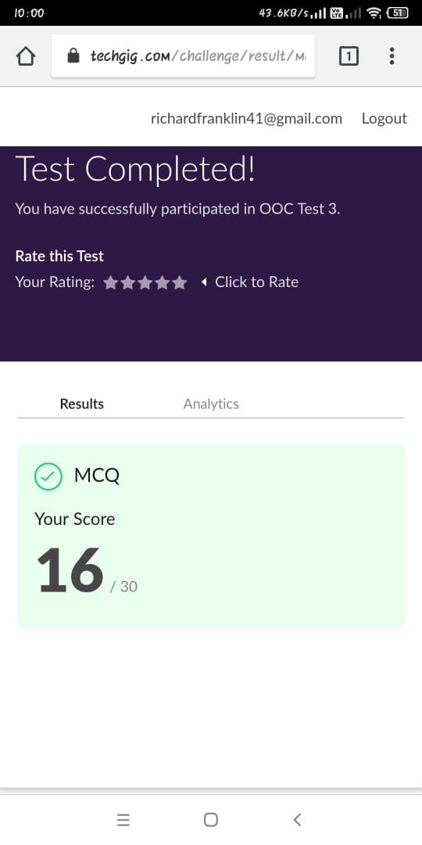

**Certification Course Details:**

**Name of the course**: Cloud Foundations

**Certificate Provider**: greatlearning

This course has 11 modules and the total duration is 5 hours.

On 03/06/2020 I went through the section of the course that explained on cloud foundations, how they are managed, important contents based on industry point of view and many more regarding the topic.

**Snapshot:**

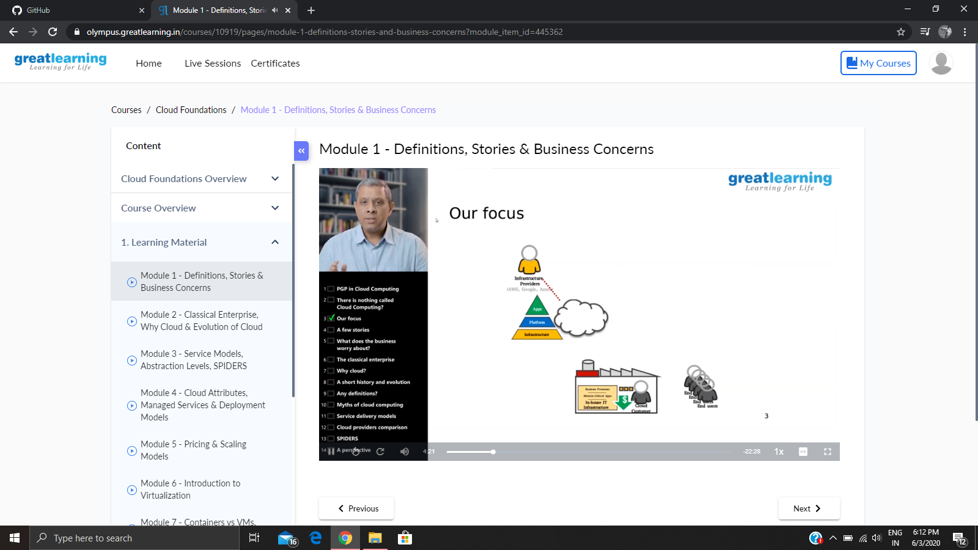

**Online Coding Details:**

Problem 1: (using Java)  [program to find Last Digit of a^b (a to the power b) for Large Numbers](https://github.com/orgs/alvas-education-foundation/teams/2nd-year/discussions/97)

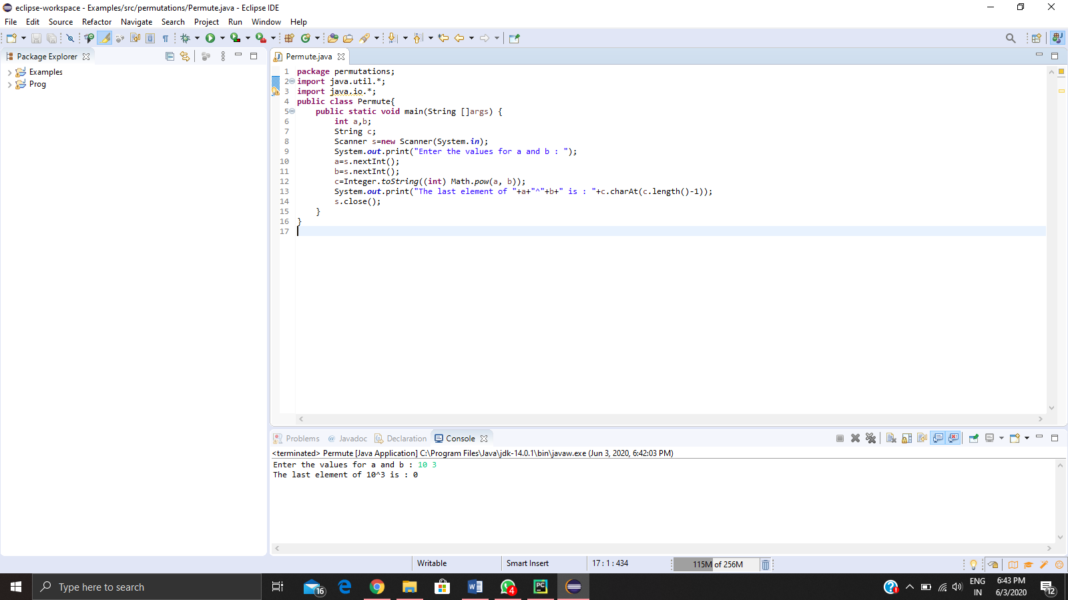

Problem 2: (using C++) [Write a function that takes a two-digit number and determines if it's the largest of two possible digit swaps.](https://github.com/orgs/alvas-education-foundation/teams/2nd-year/discussions/96)

